DOKUMENTASI EKSTERNAL  External Documentation | 
[TUGAS MANDIRI / PROYEK]
[Assignment / Project]
MATAKULIAH <COMP6176> – <Human and Computer Interaction>
Subject

SEMESTER [GANJIL/GENAP/PENDEK] 2019/2020
[Odd/Even/Compact] Semester Year 2019/2020

Judul Proyek
[Assignment / Project] Title
- Miku e-SKpo

Pendahuluan
Introduction
- Miku e-SKpo is a Music Concert from collaboration Crypton Company with Bluejacks formed in Devenber 2020 and based on Jakarta, Indonesia. Our Event invited Crypton Companies to make Concert. The concert will be held as interesting as possible, and as futuristic as possible, therefore the Crypton Company is a collaboration with bluejacks to create a web to attract fans to come.

Dokumentasi
Report / Documentation
- REPORT / PRINT SCREEN & DESCRIPTION
  - Homepage and Upcoming
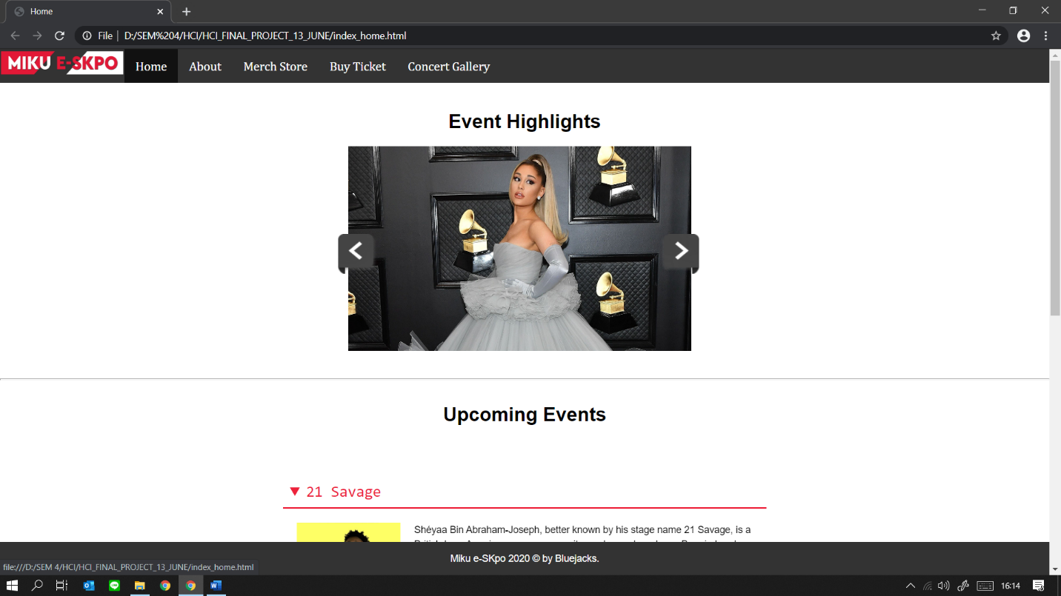
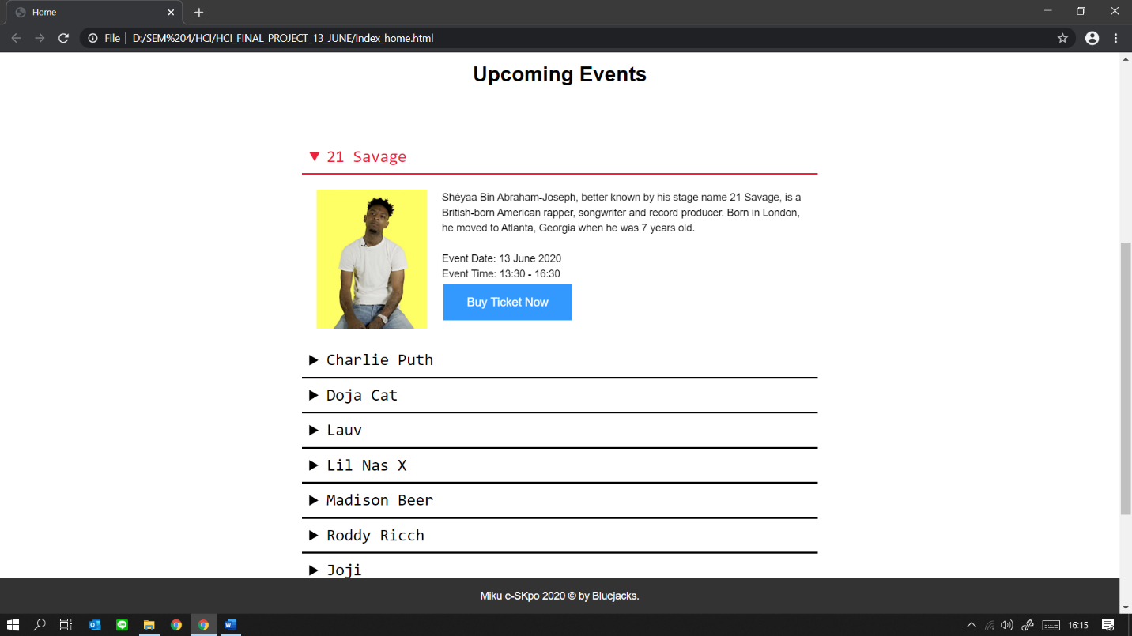
  - About
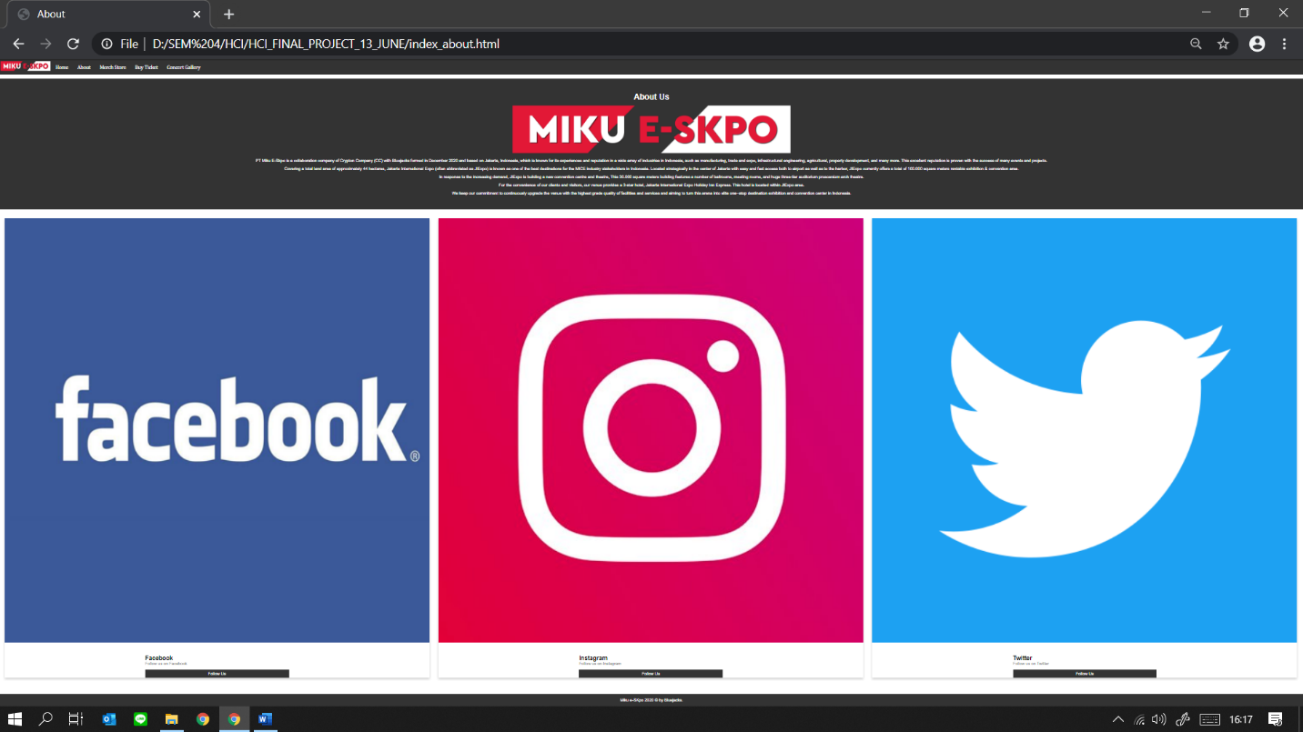
- Merch Store
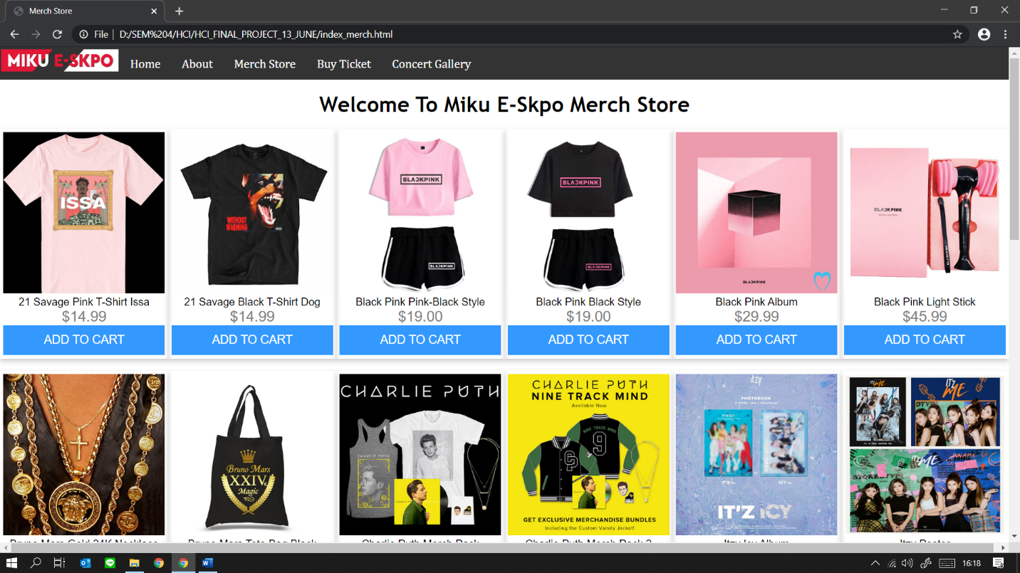
- Buy Ticket
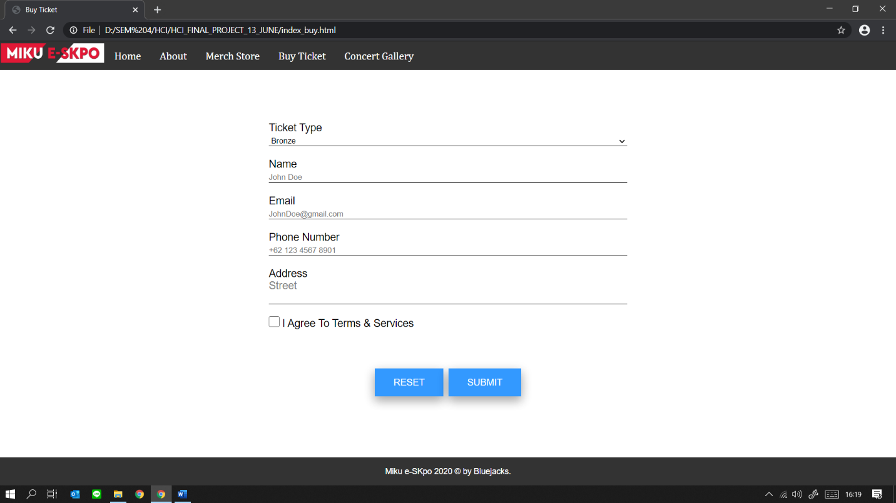
- Concert Gallery
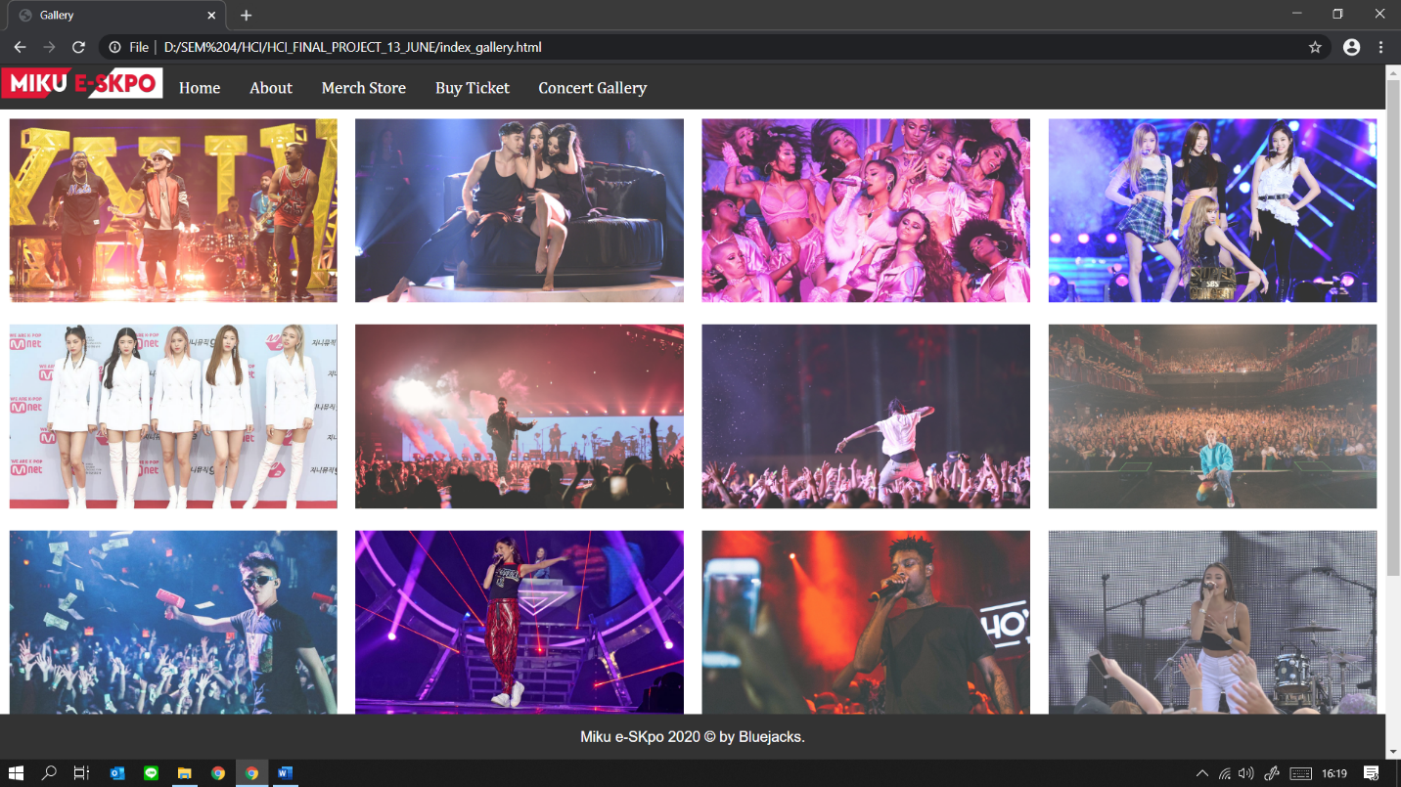

Referensi
References
- Image from google image search “bruno mars concert”
- https://21savage.com/shop
- https://shop.blackpinkmusic.com/
- https://store.brunomars.com/
- https://shop.charlieputh.com/
- https://shop.justinbiebermusic.com/
- https://shop.lauvsongs.com/
- https://shop.travisscott.com/
- https://store.roddyricch.com/
- https://genius.com/artists/21-savage
- https://genius.com/artists/Charlie-puth
- https://genius.com/artists/Doja-Cat
- https://genius.com/artists/Lauv
- https://genius.com/artists/Lil-Nas-X
- https://genius.com/artists/Madison-Beer
- https://genius.com/artists/Roddy-Ricch
- https://genius.com/artists/Joji
- https://genius.com/artists/Nicole-Zefanya
- https://genius.com/artists/Rich-Brian
- https://genius.com/artists/Big-Shaq
- https://genius.com/artists/Billie-Elish
- https://genius.com/artists/Selena-Gomez

Disiapkan Oleh,
Prepared by,
- <2201768393> - <Michael Kevin Montolalu>
- <2201759060> - <Edrick>
- <2201734676> - <Dewa Satria Ananda>

